实验四 XP开发方法，DevOps，活动图

实验目的：

1. 了解XP开发方法

2. 了解DevOps

3. 理解项目活动图

实验内容：

1. 阅读XP开发方法文档，理解XP过程工作模型

2. 阅读DevOps文档，了解DevOps

3. 活动图练习

书上练习题2,3（p97-98) 的软件开发项目活动图，找出关键路径。

小组讨论，针对自己项目中的工作进行工作活动分解，分工进行各自合理的工作进度估算，最后汇总绘出项目活动图，找出关键路径。

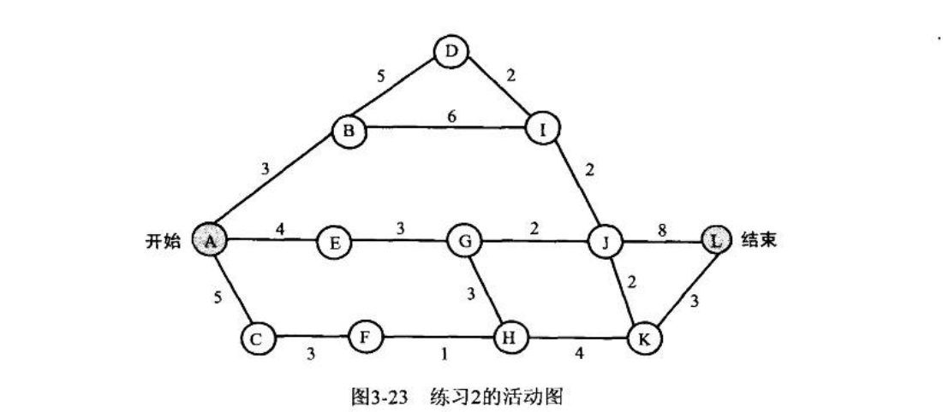

|  |  |  |  |  |  |  |  |  |  |  |  |  |
| --- | --- | --- | --- | --- | --- | --- | --- | --- | --- | --- | --- | --- |
|  | A | B | C | D | E | F | G | H | I | J | K | L |
| Ve | 0 | 3 | 5 | 8 | 4 | 8 | 7 | 10 | 10 | 12 | 14 | 20 |
| Vl | 0 | 3 | 9 | 8 | 7 | 12 | 10 | 13 | 10 | 12 | 17 | 20 |

|  |  |  |  |  |  |  |  |  |  |  |  |  |  |  |  |  |
| --- | --- | --- | --- | --- | --- | --- | --- | --- | --- | --- | --- | --- | --- | --- | --- | --- |
|  | AB | AE | AC | BD | BI | DI | EG | CF | FH | GH | GJ | HK | IJ | JK | KL | JL |
| 权重 | 3 | 4 | 5 | 5 | 6 | 2 | 3 | 3 | 1 | 3 | 2 | 4 | 2 | 2 | 3 | 8 |
| e | 0 | 0 | 0 | 3 | 3 | 8 | 4 | 5 | 8 | 7 | 7 | 10 | 12 | 12 | 14 | 12 |
| l | 0 | 3 | 4 | 3 | 4 | 8 | 7 | 9 | 12 | 10 | 10 | 13 | 10 | 15 | 17 | 12 |

关键路径是AB、BD、DI、JL

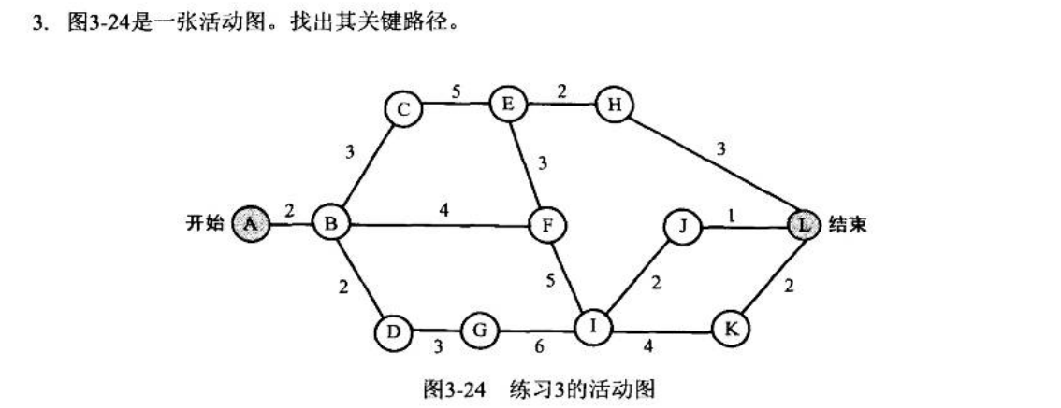

|  |  |  |  |  |  |  |  |  |  |  |  |  |
| --- | --- | --- | --- | --- | --- | --- | --- | --- | --- | --- | --- | --- |
|  | A | B | C | D | E | F | G | H | I | J | K | L |
| Ve | 0 | 2 | 5 | 4 | 10 | 13 | 7 | 12 | 18 | 20 | 22 | 24 |
| Vl | 0 | 2 | 5 | 9 | 10 | 13 | 12 | 21 | 18 | 23 | 22 | 24 |

|  |  |  |  |  |  |  |  |  |  |  |  |  |  |  |  |
| --- | --- | --- | --- | --- | --- | --- | --- | --- | --- | --- | --- | --- | --- | --- | --- |
|  | AB | BC | BD | CE | BF | DG | GI | EF | FI | EH | IJ | IK | HL | JL | KL |
| 权重 | 2 | 3 | 2 | 5 | 4 | 3 | 6 | 3 | 5 | 2 | 2 | 4 | 3 | 1 | 2 |
| e | 0 | 2 | 2 | 5 | 2 | 4 | 7 | 10 | 13 | 10 | 18 | 18 | 12 | 20 | 22 |
| l | 0 | 2 | 7 | 5 | 9 | 9 | 12 | 10 | 13 | 19 | 21 | 18 | 21 | 22 | 22 |

关键路径：AB、BC、CE、EF、FI、IK、KL

将小组工作文档、进度等文档保存到每个小组选定的协作开发平台上